VIETNAM NATIONAL UNIVERSITY, HANOI
INTERNATIONAL SCHOOL



FPT Software Human Resource Management System - Recruiter Process Concentration

Dao Duc Anh - 21070516
Pham Thi My Dung - 21070509
Luu Ha Linh - 21070757
Le Thi Hai An - 22070753
Nguyen Thi Thao - 22070643
INS306101 – Enterprise Information System, Fall 2024
MsC. Nguyen Van Cong
Department of Applied Science, International School, Vietnam National University – Hanoi
January 9th, 2025

Table of contents
Executive summary 3
System design 4
Swimlane – diagram: 4
Entity – Relationship (ER) Diagram: 6
Strong Entities: 6
Week Entities: 7
Proof of Concept (POC): Database implementation 8
SQL Queries for database establishment: 8
Testing and Validation: 11
Proof of Concept (POC): User Interface (UI) 12
Overview of the prototype: 12
Features demonstrated: 12
Conclusion and Future Orientation: 15
Summary of Achievements: 15
Next steps: 15
Vision for full-implementation: 15
References 16

List of Figures
Figure 1 Swimlane - diagram for Business Process Modelling 4
Figure 2 Entity Relationship Diagram 6
Figure 3 Physical Schema 8
Figure 4 Trigger email validation 9
Figure 5 Trigger phone number validation 9
Figure 6 Trigger time validation 10
Figure 7 Interview detail table view 11
Figure 8 Trigger evaluation range validation 11

Executive summary
FPT Software is an FPT corporation’s subsidiary and a leading global IT services provider headquartered in Hanoi, Vietnam. Established in 1999, the company has expanded its presence across 27 countries with offices in major markets, including the USA, Japan, Germany, and Singapore. Known for delivering software solutions and services across diverse industries, FPT Software has grown rapidly, leading to an increase in the complexity of managing its workforce (Leading in Digital Transformation & IT Consulting Services, 2025).
The recruitment process at FPT Software is essential to the growing requirement to acquire top-tier IT expertise, but it’s currently struggling with notable inefficiencies and obstacles. The current recruitment process is time-consuming, resulting in delayed onboarding and technically missed chances. Many tasks, like entering candidate information, scheduling interviews, combining evaluations, and communicating with applicants, are still done manually. This reliance on manual workflows often leads to delays, mistakes, and inconsistencies. As a result, operational efficiency drops, decision-making is affected, and candidates don’t have a smooth experience. It is obvious that a slothful recruitment process and poor employee experience steadily affect FPT software’s ability to attract and retain top talent resources, directly or indirectly impacting their core value of innovation and competitiveness (Leading in Digital Transformation & IT Consulting Services, 2025).
The urge for an HRM solution is undeniable. To tackle these challenges, we suggest implementing a centralized Human Resource Management System (HRMS) designed to meet FPT recruitment processes. The process includes some tasks such as candidate tracking, interview scheduling, offer management, and onboarding processes (Leading in Digital Transformation & IT Consulting Services, 2025).
To give a thorough comprehension of the process, we analyze the detailed recruitment process, visualized through a Business Process Model and Notation (BPMN) diagram. The system design features a well-defined Entity-Relationship (ER) diagram that lays out the database structure, guaranteeing a logical flow of data throughout the recruitment journey. We also confirm the system’s feasibility by implementing a structured database using SQL. To enhance the database, a prototype user interface (UI) is created to ensure a smooth user experience.
Sophisticated human resource management systems developed with database implementation showcases the potential of enterprise information systems that can help businesses like FPT Software to not only tackle the current recruitment problems but also sets the stage for ongoing improvement and innovation in managing human resources.

System design

Swimlane – diagram:
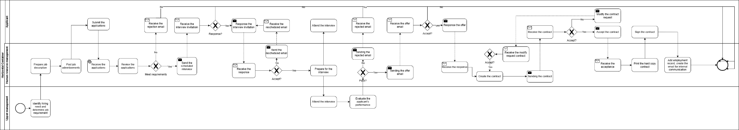

Figure 1 Swimlane - diagram for Business Process Modelling
The recruitment process in our project is designed to optimize the experience for three main user groups: Applicants, Recruiters/HR, and Upper Management. The BPMN model we developed illustrates in detail the steps of the process, from identifying recruitment needs to finalizing contracts with successful candidates.
Applicants can access the FPT Software website to search for suitable positions, register an account, or log in to submit their applications. Recruiters receive these applications and proceed to screen them based on predefined criteria. Qualified candidates are shortlisted for interviews, while those who do not meet the requirements are sent rejection emails.
During the interview phase, recruiters create interview schedules for the shortlisted candidates. These schedules are displayed on the interfaces of both applicants and upper management to ensure everyone is informed of the time and location. If the schedule changes, recruiters send notifications through the system. Both applicants and upper management attend the interviews as scheduled.
Once the interviews are completed, the system transitions to the evaluation phase. On the interfaces of recruiters and upper management, a list of candidates is displayed with the status marked as "not yet evaluated." Both groups collaborate to evaluate the candidates' performance based on mutually agreed criteria. The interface facilitates a smooth evaluation process with clear steps and functions tailored to each role.
Based on the evaluation results, recruiters decide to either accept or reject each candidate. For those who pass, recruiters send offer letters. When candidates accept the offer, the process moves to the contract phase. Recruiters create the employment contracts and upload them to the system. Applicants can view the contracts on their interfaces, along with a chat box icon to provide their feedback (accept, reject, or request modifications). If modifications are requested, the contracts are adjusted and sent back for final approval.
Once applicants approve the contracts, the signing process takes place. Applicants receive a hard copy of the signed contract, and recruiters update their profiles in the system to complete the process. Additionally, the system sends email notifications to internal departments to ensure that all relevant information is synchronized.
From our analysis of the BPMN model, we can infer that the previous recruitment process at FPT Software had several bottlenecks due to its heavy reliance on manual operations in most stages. Tasks such as application screening, managing interview schedules, sending invitations or rejection emails, evaluating candidates, and creating contracts were all done manually. This dependency on manual work increased the risk of errors and reduced overall efficiency.
Our BPMN model highlights these inefficiencies and emphasizes the need for a centralized data system. Such a system would automate many stages of the recruitment process, reduce the likelihood of errors, and improve processing speed. It would also provide a unified platform for managing all recruitment data, making it easier for recruiters, upper management, and applicants to track and complete the process seamlessly.

Entity – Relationship (ER) Diagram:
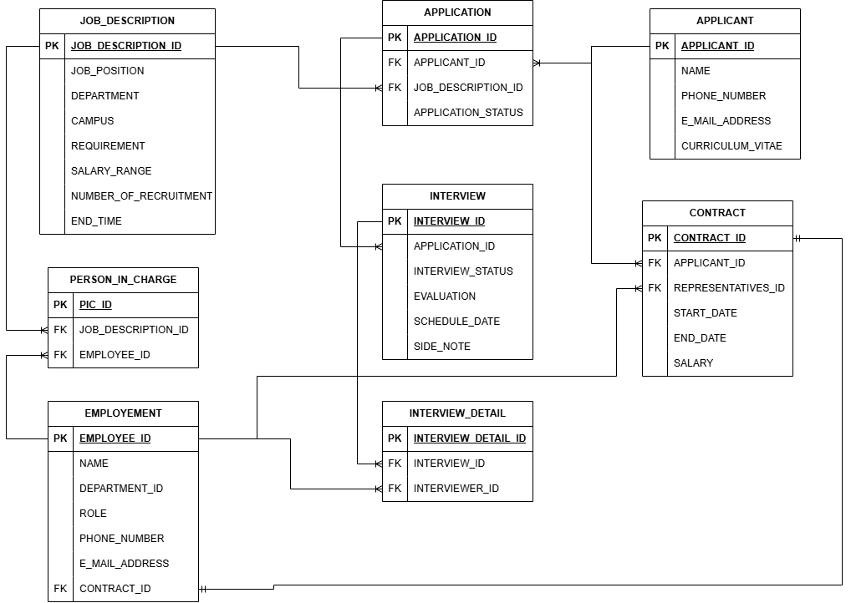

Figure 2 Entity Relationship Diagram
The ERD demonstrates the design of a database system for managing key HR operations, including recruitment, application processing, interviews, and employee management. Below is a breakdown of the entities and their relationships:
Entities and Attributes:

Strong Entities:
- JOB_DESCRIPTION: Contains details about job positions, including job title, department, campus, requirements, salary range, number of recruits, and job posting end date.
- APPLICANT: Holds applicant information such as name, contact details (phone number and email), gender, education, certifications, skills, and experience
- EMPLOYEE: Stores employee records, including name, role, department, contact details, and the associated contract.
- CONTRACT: Represents employment contracts, containing data about contract terms, representatives, start and end dates, and salaries.
- APPLICATION: Tracks job applications, connecting applicants to job descriptions and storing the current status of their applications.

Week Entities:
- INTERVIEW: Depends on APPLICATION, manages the interview process, recording the status, evaluation, schedule, and additional notes for each interview.
- INTERVIEW_DETAIL: Depends on INTERVIEW, captures specific interviewer details for each interview session.
- PERSON_IN_CHARGE: Depends on JOB_DESCRIPTION AND EMPLOYEE, links specific employees to job postings, and designates responsibility for recruitment processes.
The strong entities will be linked using bridge tables:
- PERSON_IN_CHARGE: A bridge table between EMPLOYEE and JOB_DESCRIPTION, tracking employees responsible for managing specific jobs.
- APPLICATION: A bridge table between APPLICANT and JOB_DESCRIPTION, tracking which applicant applied for which job and the application status.
- INTERVIEW_DETAIL: A bridge table between INTERVIEW and the interviewers (EMPLOYEE), storing detailed information about each interviewer participating in an interview session.
The data flow begins with the creation of new job descriptions. When a job is created, its details are stored in the JOB_DESCRIPTION table. Simultaneously, the employee responsible for the job is recorded in the PERSON_IN_CHARGE table, establishing a link between JOB_DESCRIPTION and EMPLOYEE. In the next step, when an applicant submits a job application, their personal information is stored in the APPLICANT table if it is not already present. The application details are then recorded in the APPLICATION table, linking the applicant (APPLICANT) and the job (JOB_DESCRIPTION).
Once an application is approved, the interview process is initiated. The interview schedule and related details are stored in the INTERVIEW table. Additionally, specific information about each interviewer is recorded in the INTERVIEW_DETAIL table, which links to EMPLOYEE. Finally, after the interview succeeds, the contract details are created and stored in the CONTRACT table, linking back to the applicant in the APPLICANT table. Once the applicant officially becomes an employee, their information is added to the EMPLOYEE table, establishing a connection with the CONTRACT table. This process ensures seamless data flow and integration across all stages of recruitment and employment.

Proof of Concept (POC): Database implementation

SQL Queries for database establishment:
Based on the above ERD, we use the CREATE TABLE IF NOT EXISTS command to create the tables for storing user information. Each table is designed with appropriate fields and data types to store specific information, and relationships between tables are enforced using FOREIGN KEY constraints. These constraints ensure data integrity and allow cascading actions such as ON DELETE CASCADE, maintaining consistency by deleting dependent records when the parent record is deleted.
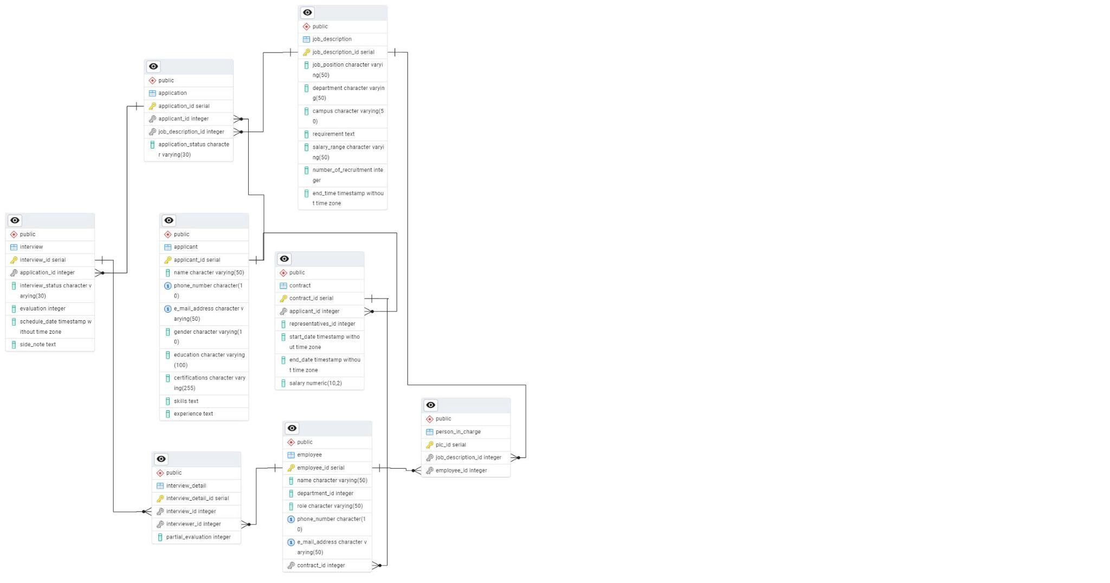

Figure 3 Physical Schema
Additionally, we use stored procedures and triggers in the database to automate calculations, validate input data, and efficiently handle changes. Triggers are activated when users perform INSERT, UPDATE, or DELETE operations, ensuring the data remains valid, logical, and consistent with business processes.
Email Validation: Triggers such as trigger_validate_applicant_email and trg_validate_employee_email are used to check the email format and ensure there are no duplicates in the APPLICANT and EMPLOYEE tables.
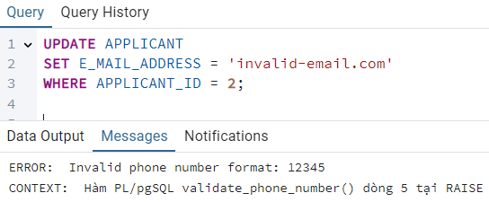

Figure 4 Trigger email validation
Phone Number Validation: Triggers like check_employee_phone_number and check_applicant_phone_number validate phone numbers using regex to ensure correct format.
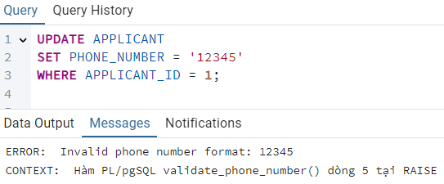

Figure 5 Trigger phone number validation
Time Validation: Triggers like validate_job_description_end_time and validate_interview_schedule_date ensure that time values (e.g., END_TIME or SCHEDULE_DATE) are in the future.
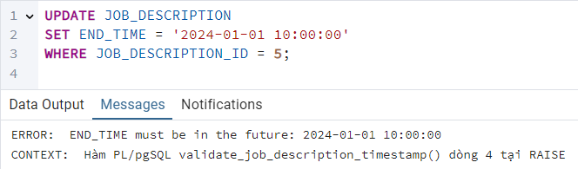

Figure 6 Trigger time validation
Automatic Calculations: The update_evaluation_trigger automatically calculates the average evaluation value (EVALUATION) based on partial evaluations (partial_evaluation) from the INTERVIEW_DETAIL tableA. The check_partial_evaluation trigger ensures the evaluation value is between 0 and 100.
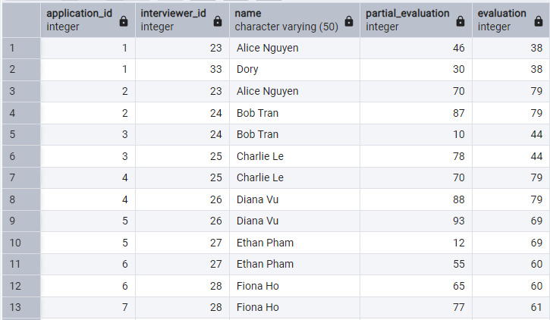

Figure 7 Interview detail table view
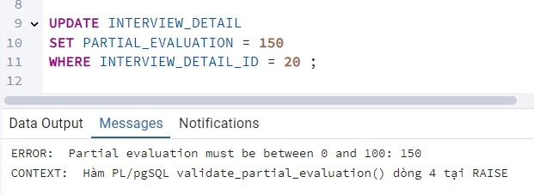

Figure 8 Trigger evaluation range validation
Schedule Conflict Detection: Triggers like check_interview_schedule and check_interviewer_schedule check if there are scheduling conflicts for candidates or interviewers during interview scheduling.
Update Procedures: The update_schedule_date procedure allows automatic updating of interview times to simplify schedule management. Procedures like update_application_status and update_interview_status are used to change the status of applications or interviews, ensuring that data is updated accurately.

Testing and Validation:
Our system provides HR managers with comprehensive tools to streamline the recruitment process. It allows for easy tracking and analysis of recruitment data, from monitoring applicants' progress to checking historical data. Data integrity is ensured through automated validation checks, such as email and phone number formatting, and time validation for job descriptions and interviews. The system also automates calculations, like averaging interview evaluations, and updates the status of applications and interviews to reduce manual input errors. It helps detect scheduling conflicts for interviews, ensuring smooth coordination. Additionally, HR managers can easily generate reports and make data-driven decisions based on detailed queries, optimizing the entire recruitment workflow.

Proof of Concept (POC): User Interface (UI)

Overview of the prototype:
The recruitment processing prototype is designed to streamline the hiring workflow for recruiters, upper management, and applicants through an intuitive and sequential user interface. It incorporates three distinct user roles: recruit, applicant, and upper management. Each role is supported by tailored screens and features that facilitate efficient collaboration and decision-making throughout the recruitment lifecycle (New employees, 2025).
The process begins with the recruiter's screen, from job posting and application submission to applicant evaluation and contract management. By providing logical function design based on recruitment processing, and structured workflows, this system improves experience for recruiters. Besides that, applicants can easily access an intuitive interface to submit applications, attend interviews, and track contract statuses. Upper management plays a key role in checking, attending interviews, and reviewing evaluations. This prototype not only simplifies the complex hiring process, but also promotes transparency, objectivity, and collaboration between individuals, ensuring that the hiring process is smooth, easy, and efficient for all parties involved.

Features demonstrated:
Screen | Features | Explanation
Recruit | Filter search, create new position, upload job position | Employers easily find suitable candidates and set up new job positions with the necessary documentation.
 | Check the status of other recruiters | View other recruiters' tasks to get an overview of the task
 | Check the status of the job: to recruit, date end,... | Check time is left to close a job, expired jobs will be automatically pushed down.
 | Shortlist applicants based on qualifications (accept or reject) | Narrow down candidate lists based on specific criteria to increase screening efficiency.
 | Search, and filter applicants | Search for candidate information and sort application information in order such as scores,...
 | Check & set the schedule | Helps employers easily find suitable candidates and set up new job positions with the necessary documentation.
 | View and evaluate applicants after interviews | Provide candidate information and support direct post-interview assessment for data storage.
 | Decide on acceptance or rejection, and export evaluations | Allows storing and exporting assessment results to make decisions about interview approval
 | Download, edit, and upload contracts | Support contract management between candidates and companies, including flexible editing and sending.
 | Check status contract | Show contract status (submitted, rejected, etc.) to track progress.
Applicants | Sign In to the System | Provide access to the system to start the application process and track job progress.
 | Alternative Login Methods | Quick login via Facebook or Google saves time and offers applicants convenience.
 | Fill Out Personal Information | Applicants fill in personal details such as full name, phone number, email, gender, education level, certifications, skills, and work experience.
 | Submit Application | Click the "Submit Now" button to send their application. Their information will be transferred to the recruitment system for processing and storage.
 | View Applied Jobs | View other positions they’ve applied for, including job title, application date, assigned recruiter, and the current status (Initial Qualification, Interview, Contract, Fail).
 | Receive Interview Schedules | Provide detailed information about interview times and locations.
 | Respond to Interview Schedules | Applicants can choose "Attend" or "Reject" the interview schedule if the time doesn’t fit their availability.
 | View and Respond to Contracts | Applicants can choose to "Accept" or "Reject" the job contract. If they reject it, they can provide specific reasons for the recruiter to consider and possibly adjust the terms.
Upper Management | Check Interview Schedules | Managers can review and track interview schedules for applicants, including time details and applicant names.
 | Respond to Interview Invitations | Managers can select "Attend" or "Reject" an interview if the schedule isn’t suitable. In case of rejection, they can coordinate with recruiters to adjust the interview schedule.
 | View and Evaluate Applicants After Interviews | Provide candidate information and support direct post-interview assessments for data storage.

Conclusion and Future Orientation:

Summary of Achievements:
The proposed Human Resource Management System for FPT Software overcomes existing problems in the recruitment process by moving away from manual operations. By utilizing BPMN analysis, Entity-Relationship diagrams and database implementation, the system achieves significant achievements like smoother workflows, organized data management, and enhanced operational efficiency through automated features such as calculating interviewer scores. Moreover, the user-friendly prototype showcases features like applicant tracking, evaluation management, and reporting, proving that the system is both practical and effective in improving recruitment operations.

Next steps:
Moving forward with FPT Software's suggested Human Resource Management system, the next step is to develop the current prototype into a fully functional HRMS. This will feature a strong back-end and ensure real-time data synchronization while being seamlessly integrated with the company's existing IT setup. We'll conduct user testing involving HR staff and hiring managers to gather feedback on the system’s features, design, and overall performance for further enhancements. We also plan to carry out advanced features like predictive analytics and machine learning models to help with applicant ratings, alongside implementing security measures to guarantee compliance with data protection regulations.

Vision for full-implementation:
The goal of deploying FPT Software's Human Resource Management system is to create a comprehensive recruiting ecosystem that manages every aspect of the hiring process, from job postings to onboarding. This solution will provide real-time insights and data-driven recommendations to support strategic workforce planning, enabling managers to make better-informed decisions. Additionally, it also provides the groundwork for larger HR digitization initiatives, establishing FPT Software as a market leader in tech-enabled people management.

References
Leading in Digital Transformation & IT Consulting Services. (2025, 1 8). Được truy lục từ FPT Software: https://fptsoftware.com/#global-presense
Leading in Digital Transformation & IT Consulting Services. (2025, 1 8). Được truy lục từ FPT Software: https://fptsoftware.com/#services-solutions
Leading in Digital Transformation & IT Consulting Services. (2025, 1 8). Được truy lục từ FPT Software: https://fptsoftware.com/#in-the-news
New employees. (2025, 1 8). Được truy lục từ Odoo: https://www.odoo.com/documentation/18.0/applications/hr/employees/new_employee.html

